Test Case: tc001_SPX_Dev5_Crear_Solicitud_Articulo_Almacen
Step 1 - Enter username and password and click to button Enter : Credentials Entered
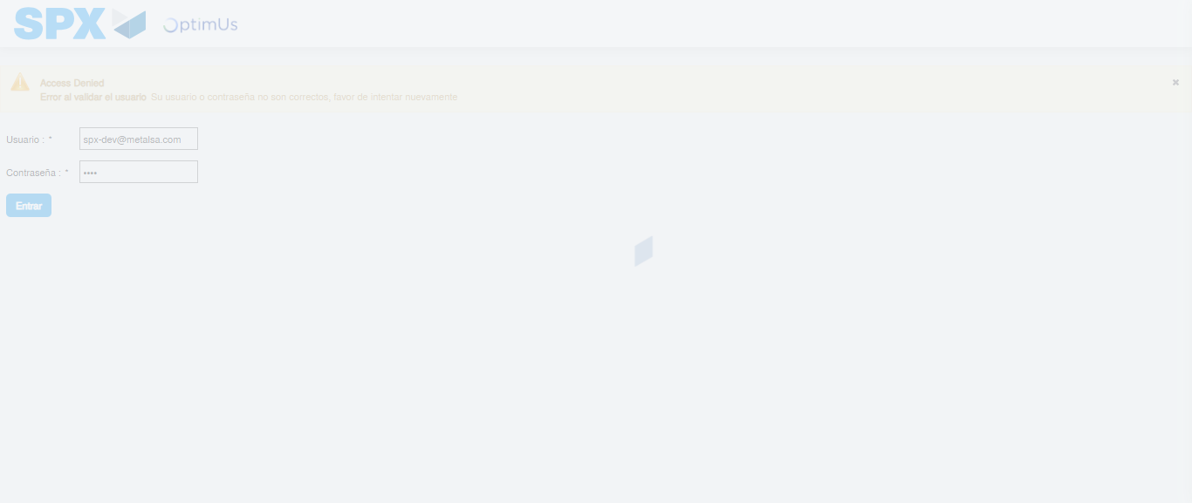Image file-name: QC_Testing-tc001_SPX_Dev5_Crear_Solicitud_Articulo_Almacen-1787867721521

Step 2 - Select to UEN and Access to Request for a New Inventory Item : UEN Correctly selected and Correct access
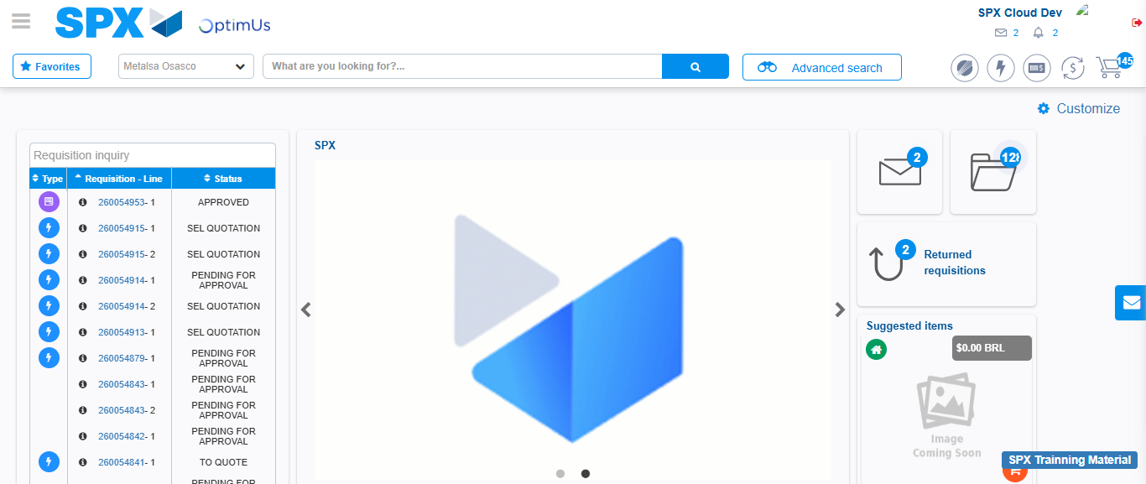Image file-name: QC_Testing-tc001_SPX_Dev5_Crear_Solicitud_Articulo_Almacen-1787867747026

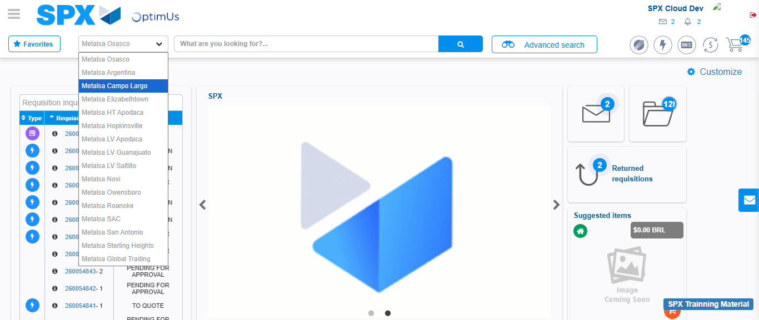Image file-name: QC_Testing-tc001_SPX_Dev5_Crear_Solicitud_Articulo_Almacen-1787867747714

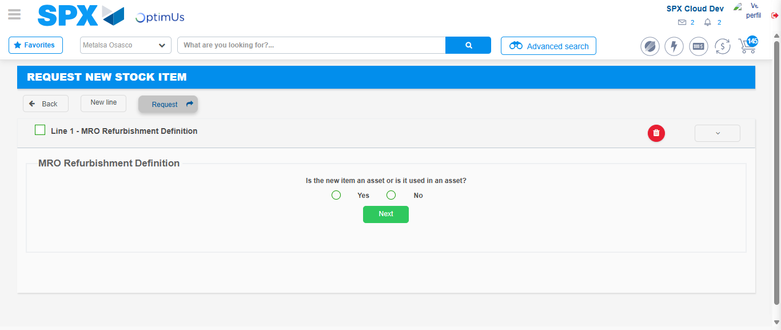Image file-name: QC_Testing-tc001_SPX_Dev5_Crear_Solicitud_Articulo_Almacen-1787867766444

Step 3 - Select options first section : Options seleted correctly
Image file-name: QC_Testing-tc001_SPX_Dev5_Crear_Solicitud_Articulo_Almacen-1787867766699

Image file-name: QC_Testing-tc001_SPX_Dev5_Crear_Solicitud_Articulo_Almacen-1787867766882

Step 4 - Select options at Screen: Options seleted correctly
Image file-name: QC_Testing-tc001_SPX_Dev5_Crear_Solicitud_Articulo_Almacen-1787867766699

Image file-name: QC_Testing-tc001_SPX_Dev5_Crear_Solicitud_Articulo_Almacen-1787867766882

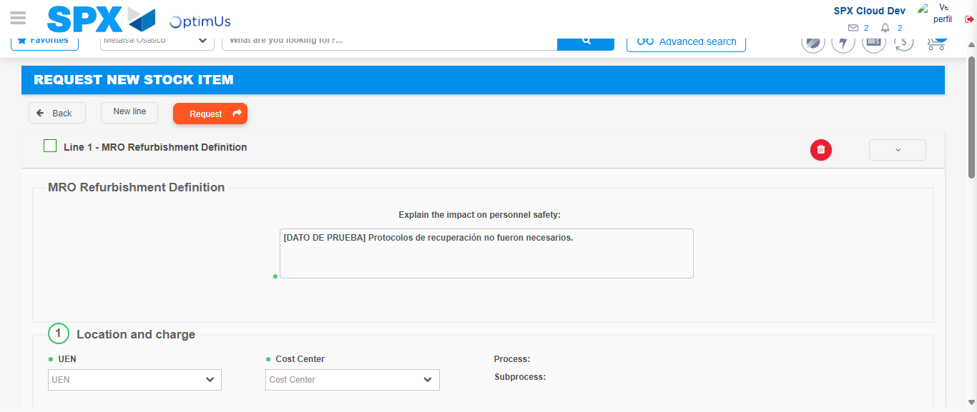Image file-name: QC_Testing-tc001_SPX_Dev5_Crear_Solicitud_Articulo_Almacen-1787867773821

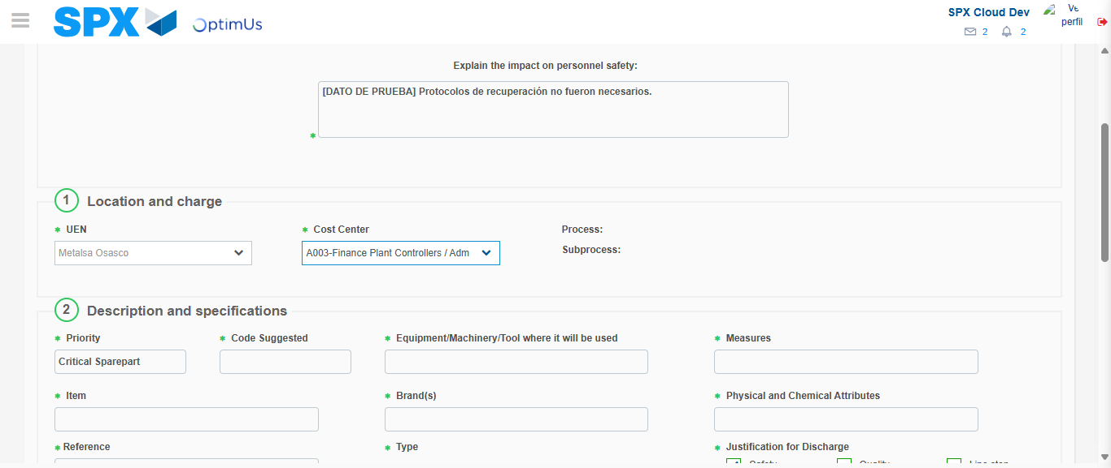Image file-name: QC_Testing-tc001_SPX_Dev5_Crear_Solicitud_Articulo_Almacen-1787867776817

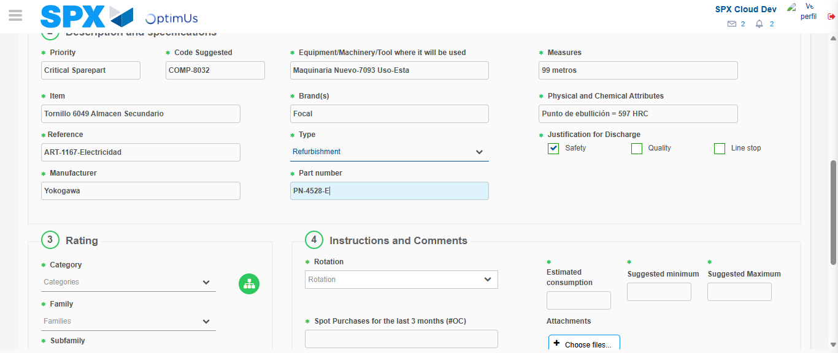Image file-name: QC_Testing-tc001_SPX_Dev5_Crear_Solicitud_Articulo_Almacen-1787867778673

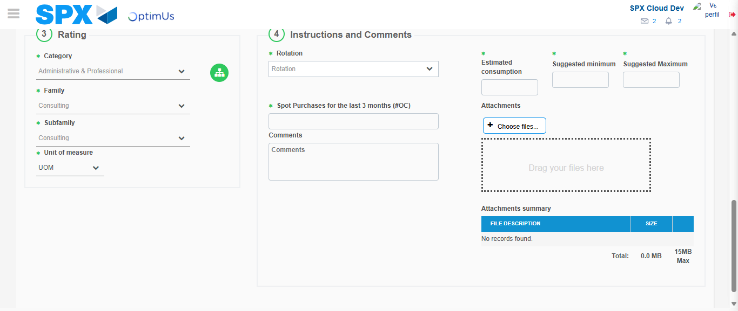Image file-name: QC_Testing-tc001_SPX_Dev5_Crear_Solicitud_Articulo_Almacen-1787867782621

Step 7 - Return to Main Page SPX : Return to Main Page SPX
Image file-name: QC_Testing-tc001_SPX_Dev5_Crear_Solicitud_Articulo_Almacen-1787867747026

Image file-name: QC_Testing-tc001_SPX_Dev5_Crear_Solicitud_Articulo_Almacen-1787867747714

Image file-name: QC_Testing-tc001_SPX_Dev5_Crear_Solicitud_Articulo_Almacen-1787867766444

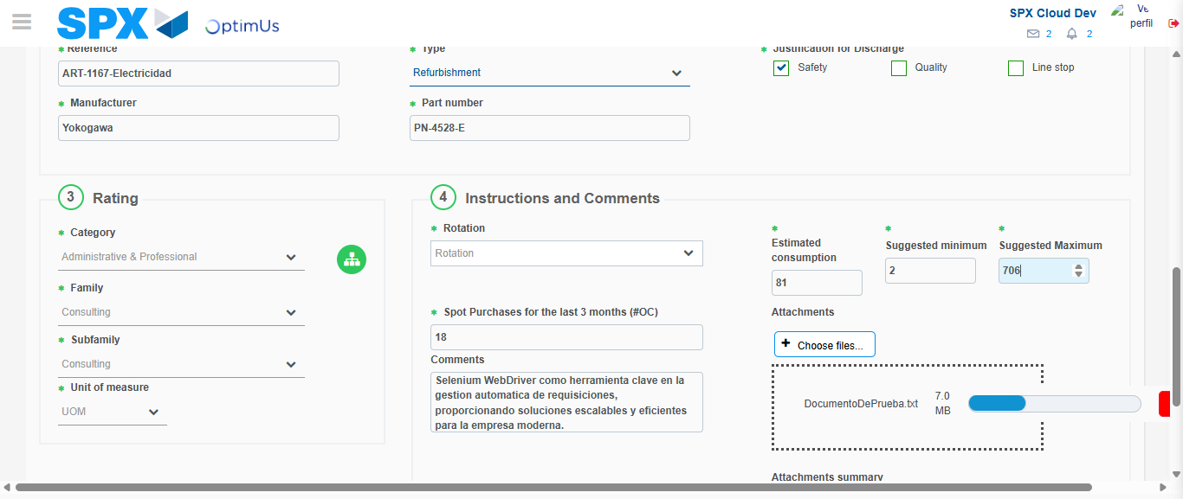Image file-name: QC_Testing-tc001_SPX_Dev5_Crear_Solicitud_Articulo_Almacen-1787867786588

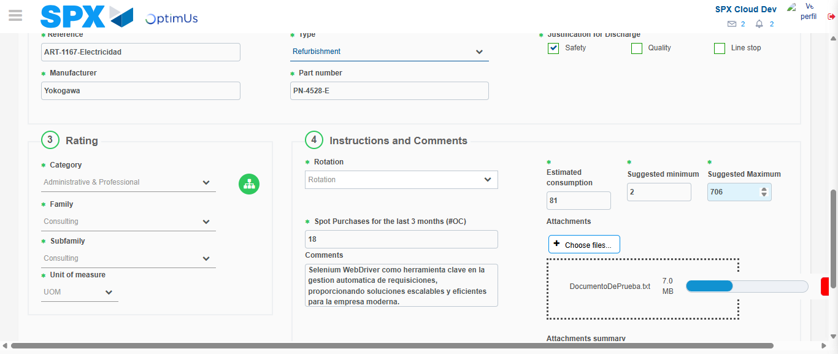Image file-name: QC_Testing-tc001_SPX_Dev5_Crear_Solicitud_Articulo_Almacen-1787867786799

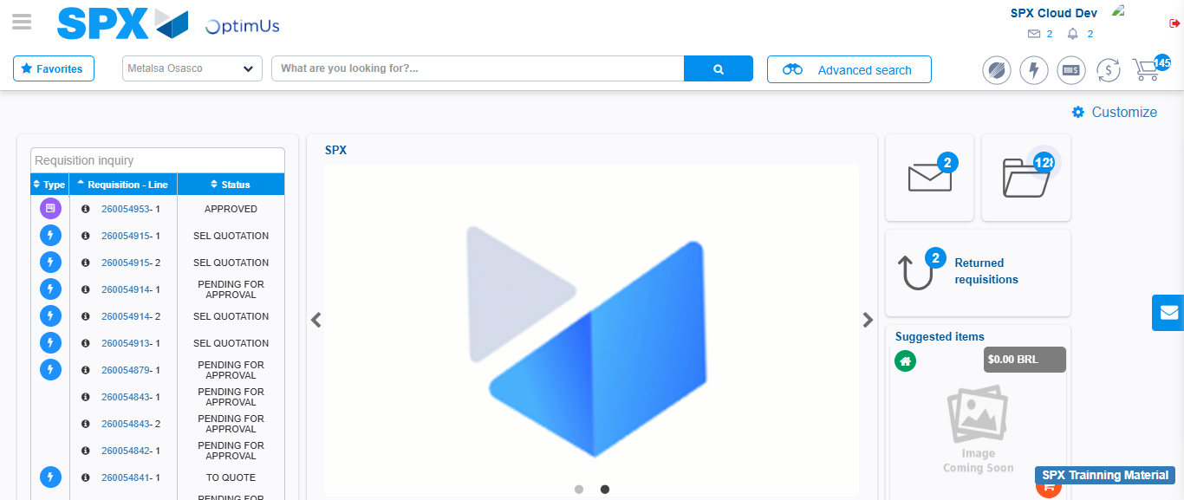Image file-name: QC_Testing-tc001_SPX_Dev5_Crear_Solicitud_Articulo_Almacen-1787867808195

Step 8 - Log Out : Log Out SPX
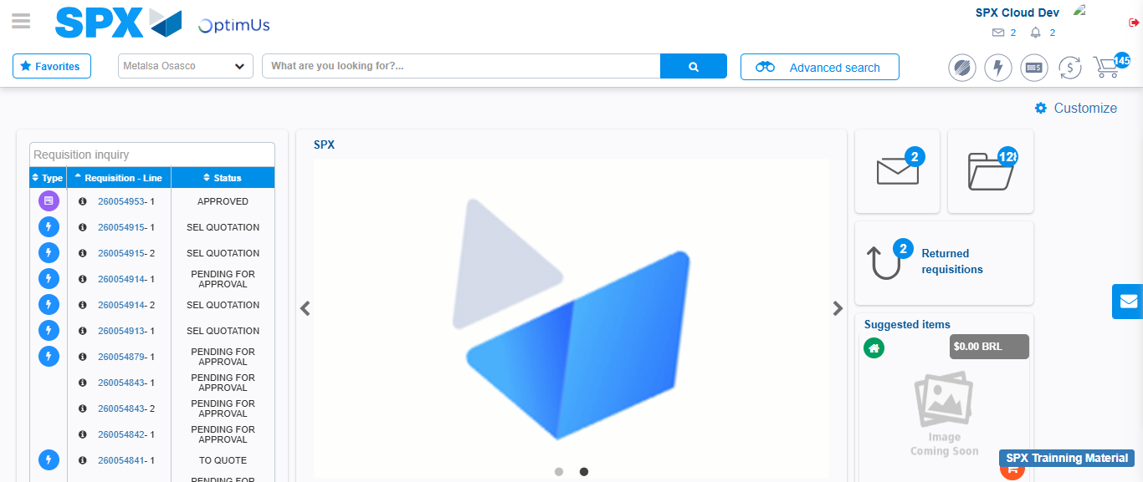Image file-name: QC_Testing-tc001_SPX_Dev5_Crear_Solicitud_Articulo_Almacen-1787867808498

